Social Media Post Samples
- The following images can be used as a template for social media posts when you are promoting the Lever Action Plate System® at your facility.
- You may recreate them by copying the text below them into their respective social media sites.
- These social media posts can be used in conjunction with the images and logos provided in this press kit, your own internal pictures, and other media you create about the Lever Action Plate System®.
- If you require anything further from us, please submit your request to the Education Manager, Leann Roggensack, by email at leann@mcginleyinnovations.com or by phone at 615-767-1985.

Facebook
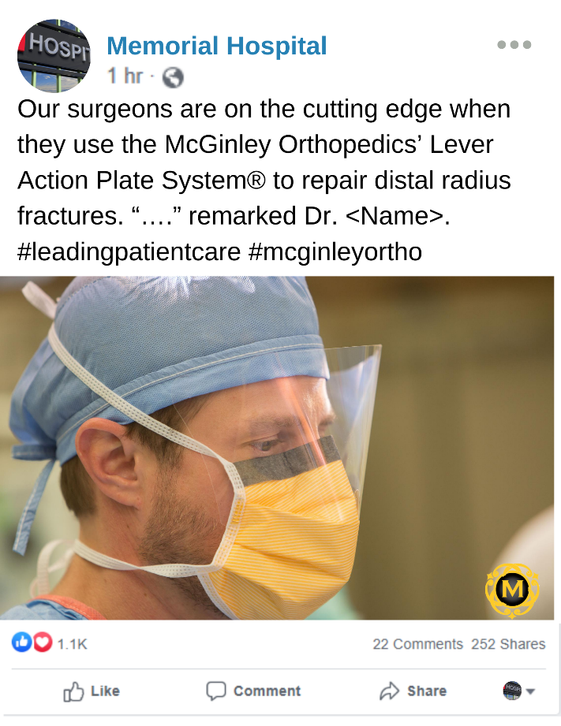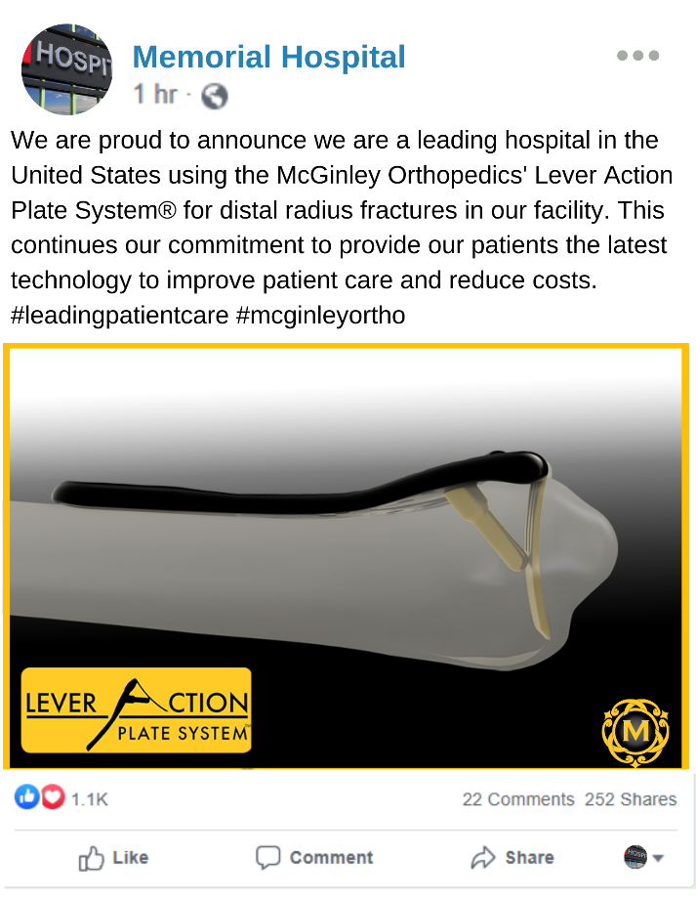
We are proud to announce we are a leading hospital in the United States using the McGinley Orthopedics’ Lever Action Plate System® for distal radius fractures in our facility. This continues our commitment to provide our patients the latest technology to improve patient care and reduce costs. #leadingpatientcare #mcginleyortho
Copy the text in the bottom box into your Facebook post.
You can use a photo of one of our plates. Please make sure to include the hashtags #leadingpatientcare and #mcginleyortho
Our surgeons are on the cutting edge when they use the McGinley Orthopedics’ Lever Action Plate System® to repair distal radius fractures. “….” remarked Dr. <Name>. #leadingpatientcare #mcginleyortho
Copy the text in the bottom box into your Facebook post.
You can use a photo of one of your surgeons or staff members. You can also use a quote from them. Please make sure to include the hashtags #leadingpatientcare and #mcginleyortho

Instagram
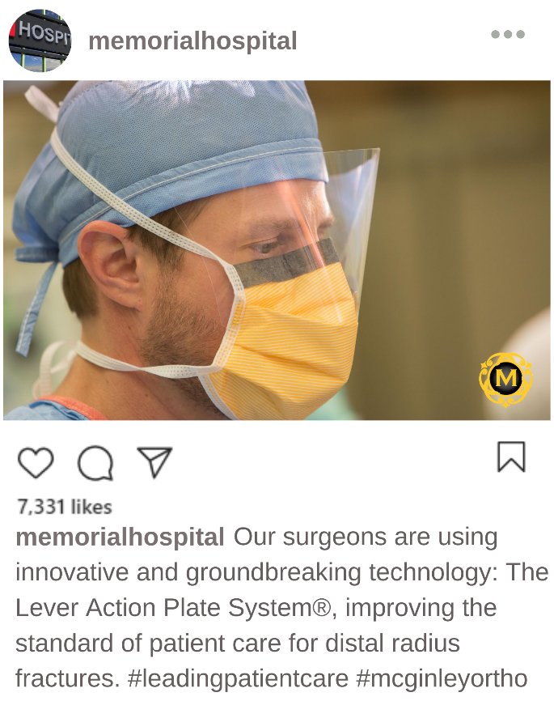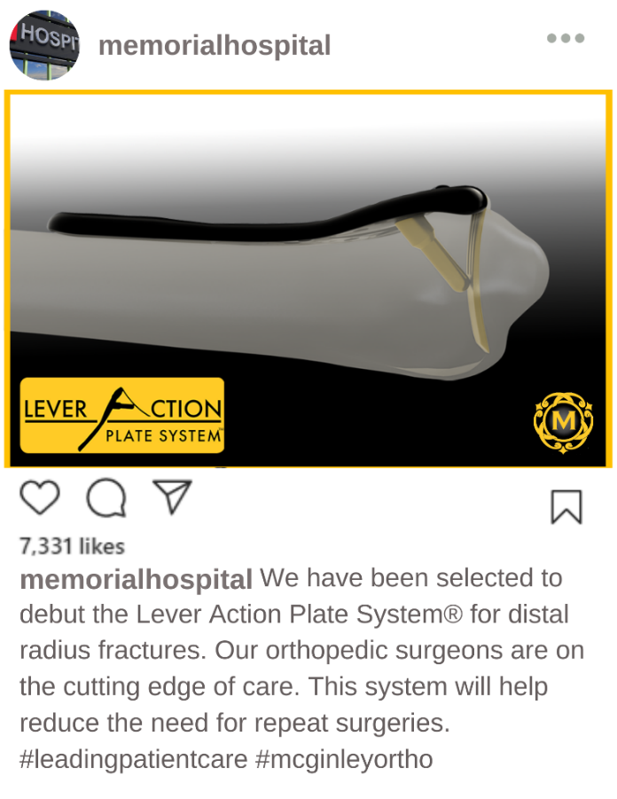
We have been selected to debut the Lever Action Plate System® for distal radius fractures. Our orthopedic surgeons are on the cutting edge of care. This system will help reduce the need for repeat surgeries. #leadingpatientcare #mcginleyortho
Our surgeons are using innovative and groundbreaking technology: The Lever Action Plate System®, improving the standard of patient care for distal radius fractures. #leadingpatientcare #mcginleyortho
Copy the text in the bottom box into your Instagram post.
You can use a photo of one of our plates. Please make sure to include the hashtags #leadingpatientcare and #mcginleyortho
Copy the text in the bottom box into your Instagram post.
You can use a photo of one of your surgeons or staff members. Please make sure to include the hashtags #leadingpatientcare and #mcginleyortho

Twitter
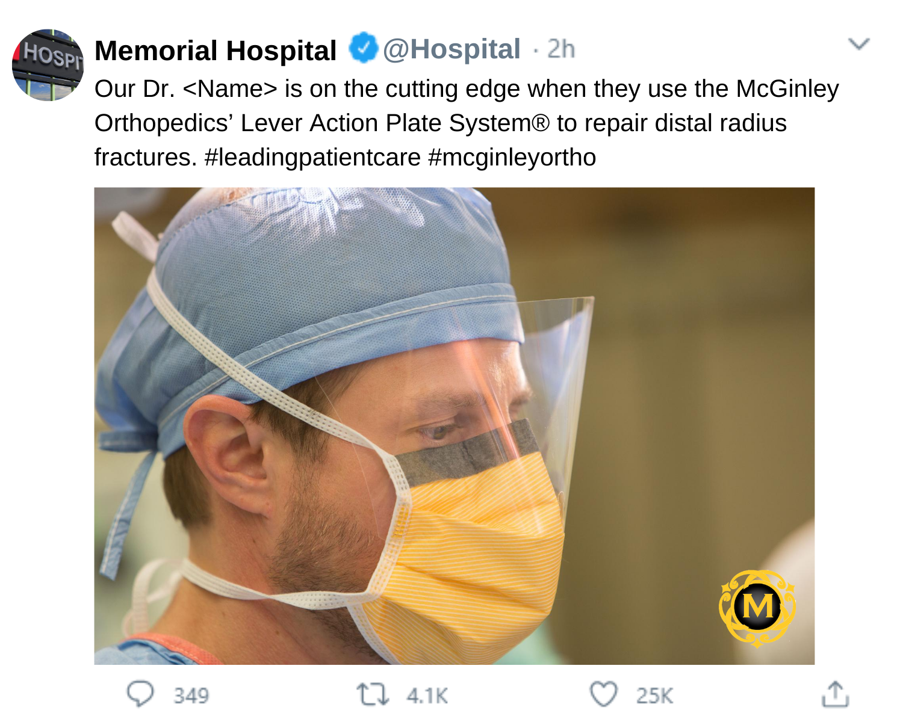
Copy the text in the bottom box into your Twitter post.
You can use a photo of one of your surgeons or staff members. Please make sure to include the hashtags #leadingpatientcare and #mcginleyortho

Our Dr. <Name> is on the cutting edge when they use the McGinley Orthopedics’ Lever Action Plate System® to repair distal radius fractures. #leadingpatientcare #mcginleyortho

Twitter
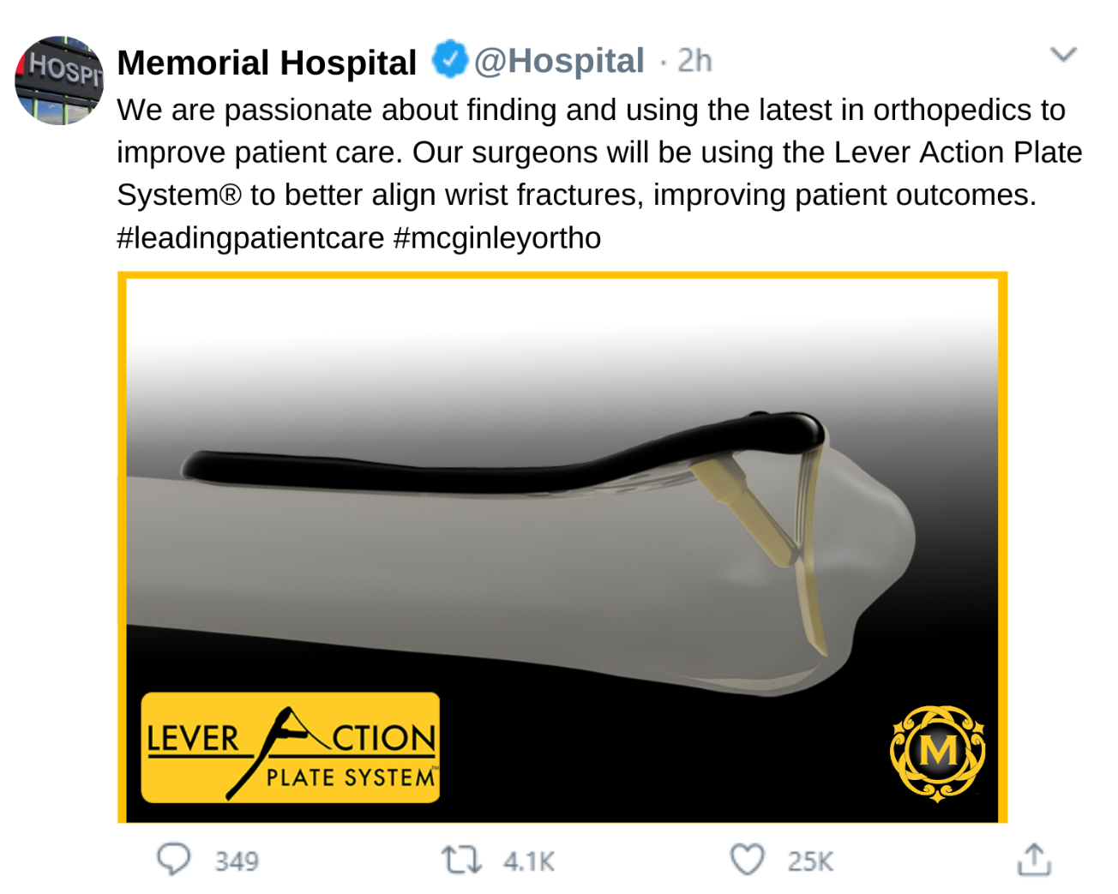
Copy the text in the bottom box into your Twitter post.
You can use a photo of one of our plates. Please make sure to include the hashtags #leadingpatientcare and #mcginleyortho

We are passionate about finding and using the latest in orthopedics to improve patient care. Our surgeons will be using the Lever Action Plate System® to better align wrist fractures, improving patient outcomes. #leadingpatientcare #mcginleyortho

Linkedin
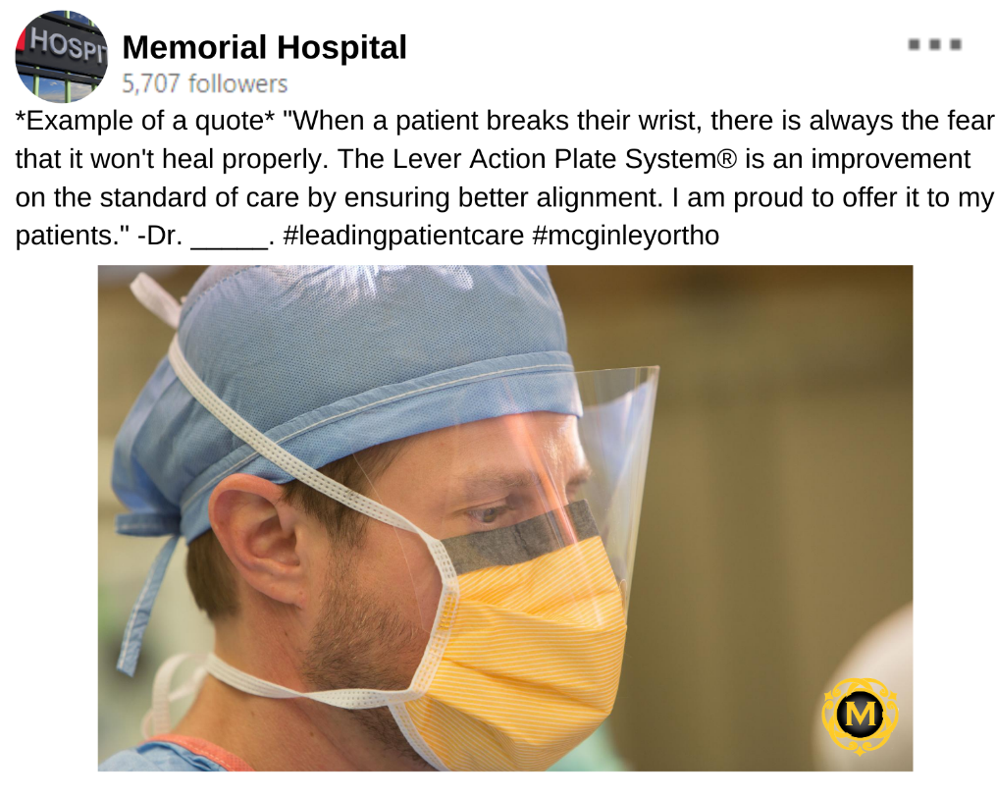
This text includes an example of a quote that could be used in your Linkedin post. You can use a quote from one of your staff members that is similar.
You can use a photo of one of your surgeons or staff members. Please make sure to include the hashtags #leadingpatientcare and #mcginleyortho

*Example of a quote* "When a patient breaks their wrist, there is always the fear that it won't heal properly. The Lever Action Plate System® is an improvement on the standard of care by ensuring better alignment. I am proud to offer it to my patients." -Dr. _____. #leadingpatientcare #mcginleyortho

Linkedin
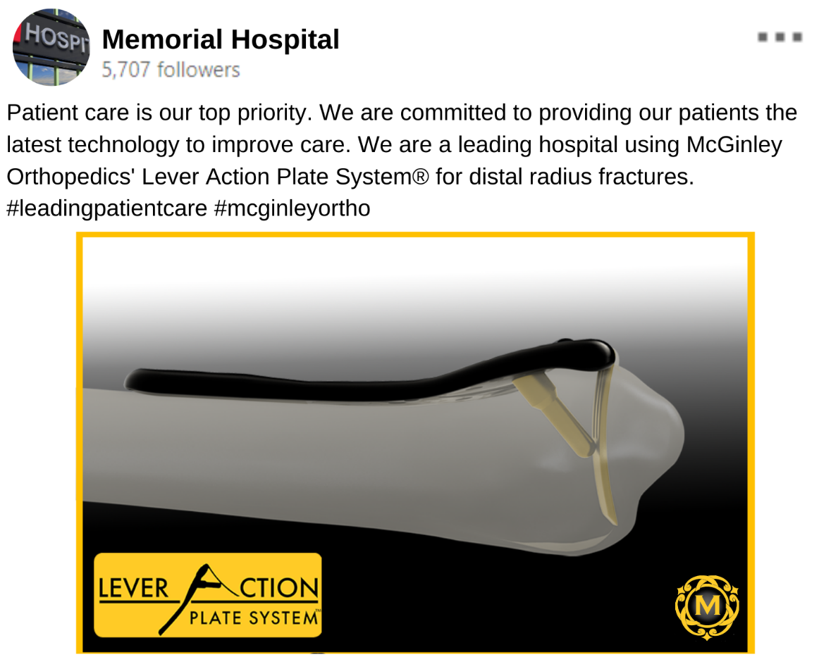
Copy the text in the bottom box into your Linkedin post.
You can use a photo of one of our plates. Please make sure to include the hashtags #leadingpatientcare and #mcginleyortho

Patient care is our top priority. We are committed to providing our patients the latest technology to improve care. We are a leading hospital using McGinley Orthopedics' Lever Action Plate System® for distal radius fractures. #leadingpatientcare #mcginleyortho

